**Anniversary Products**

# **1.Simply Decorated:**

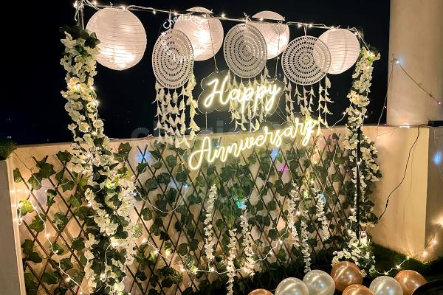**At [Your Business Name], we specialize in crafting exquisite anniversary flower decorations that commemorate love and cherished memories. With a deep understanding of the significance of anniversaries, we curate elegant and personalized floral arrangements that reflect your unique journey as a couple. Our dedicated team collaborates closely with you to create romantic and sentimental setups, from breathtaking tablescapes to heartfelt bouquet designs. Whether you're celebrating your first year or a milestone anniversary, our attention to detail and commitment to excellence ensure that your special day is adorned with the beauty and fragrance of fresh blooms. Let our floral masterpieces add a touch of romance and joy to your anniversary celebrations, creating a memorable experience that symbolizes your enduring love.**

# **2.Our Anniversary Delight:**

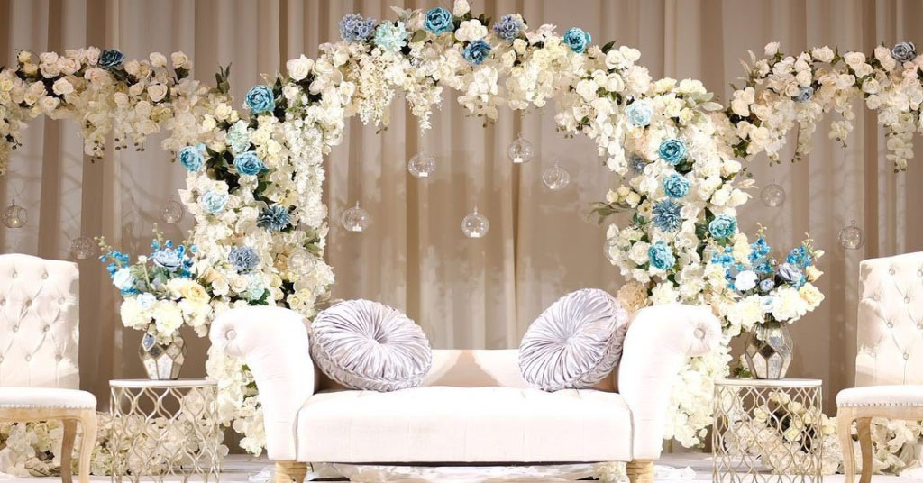**At [Your Business Name], we specialize in crafting exquisite anniversary flower decorations that commemorate love and cherished memories. With a deep understanding of the significance of anniversaries, we curate elegant and personalized floral arrangements that reflect your unique journey as a couple. Our dedicated team collaborates closely with you to create romantic and sentimental setups, from breathtaking tablescapes to heartfelt bouquet designs. Whether you're celebrating your first year or a milestone anniversary, our attention to detail and commitment to excellence ensure that your special day is adorned with the beauty and fragrance of fresh blooms. Let our floral masterpieces add a touch of romance and joy to your anniversary celebrations, creating a memorable experience that symbolizes your enduring love.**

# **3.Grand Anniversary:**

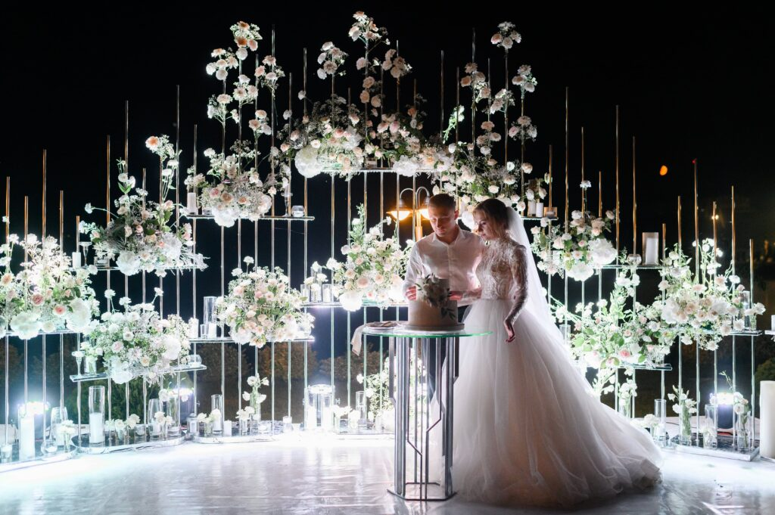**At [Your Business Name], we specialize in crafting exquisite anniversary flower decorations that commemorate love and cherished memories. With a deep understanding of the significance of anniversaries, we curate elegant and personalized floral arrangements that reflect your unique journey as a couple. Our dedicated team collaborates closely with you to create romantic and sentimental setups, from breathtaking tablescapes to heartfelt bouquet designs. Whether you're celebrating your first year or a milestone anniversary, our attention to detail and commitment to excellence ensure that your special day is adorned with the beauty and fragrance of fresh blooms. Let our floral masterpieces add a touch of romance and joy to your anniversary celebrations, creating a memorable experience that symbolizes your enduring love.**

# **4.Home Decorations:**

**At [Your Business Name], we specialize in crafting exquisite anniversary flower decorations that commemorate love and cherished memories. With a deep understanding of the significance of anniversaries, we curate elegant and personalized floral arrangements that reflect your unique journey as a couple. Our dedicated team collaborates closely with you to create romantic and sentimental setups, from breathtaking tablescapes to heartfelt bouquet designs. Whether you're celebrating your first year or a milestone anniversary, our attention to detail and commitment to excellence ensure that your special day is adorned with the beauty and fragrance of fresh blooms. Let our floral masterpieces add a touch of romance and joy to your anniversary celebrations, creating a memorable experience that symbolizes your enduring love.**

# **5.Anniversary Shoot:**

**At [Your Business Name], we specialize in crafting exquisite anniversary flower decorations that commemorate love and cherished memories. With a deep understanding of the significance of anniversaries, we curate elegant and personalized floral arrangements that reflect your unique journey as a couple. Our dedicated team collaborates closely with you to create romantic and sentimental setups, from breathtaking tablescapes to heartfelt bouquet designs. Whether you're celebrating your first year or a milestone anniversary, our attention to detail and commitment to excellence ensure that your special day is adorned with the beauty and fragrance of fresh blooms. Let our floral masterpieces add a touch of romance and joy to your anniversary celebrations, creating a memorable experience that symbolizes your enduring love.**

# **6.Anniversary Card:**

**At [Your Business Name], we specialize in crafting exquisite anniversary flower decorations that commemorate love and cherished memories. With a deep understanding of the significance of anniversaries, we curate elegant and personalized floral arrangements that reflect your unique journey as a couple. Our dedicated team collaborates closely with you to create romantic and sentimental setups, from breathtaking tablescapes to heartfelt bouquet designs. Whether you're celebrating your first year or a milestone anniversary, our attention to detail and commitment to excellence ensure that your special day is adorned with the beauty and fragrance of fresh blooms. Let our floral masterpieces add a touch of romance and joy to your anniversary celebrations, creating a memorable experience that symbolizes your enduring love.**